Policy on the Safeguarding of Children and Adults
in the Church Parish of Forest Row
(Serving the villages of Ashurst Wood, Forest Row, Hammerwood)

This policy statement was adopted by the Parochial Church Council at its meeting on 19 May 2022.
This policy will be reviewed each year to monitor the progress that has been achieved.

1. We recognize that everyone has different levels of vulnerability and that each of us may be regarded as vulnerable at some time in our lives.

2. As member of this parish we commit ourselves to respectful pastoral care for all children and adults to whom we minister.

3. We commit ourselves to the safeguarding of people who may be vulnerable, ensuring their wellbeing in the life of this church.

4. We commit ourselves to promoting safe practice by those in positions of trust.

5. The parish commits itself to promoting the inclusion and empowerment of people who may be vulnerable.

6. It is the responsibility of each of us to prevent the physical, emotional, sexual, financial, and spiritual abuse of vulnerable people and to report any such abuse that we discover or suspect.

7. We undertake to exercise proper care in the appointment and selection of those who will work with people who may be vulnerable.

8. The parish is committed to supporting, resourcing, training and regularly reviewing those who undertake work amongst people who may be vulnerable.

9. The parish adopts the guideline of the Church of England and the Diocese.

10. Each person who works with vulnerable people will agree to abide by these recommendations and the guidelines established by the parish.

The Parish appoints Marilyn Morris to represent the concerns and views of vulnerable people at its meetings and to outside bodies, as the Parish Safeguarding Officer.
Telephone number: 01342 823940 or 07746 736224
Email: marilyn1955morris@gmail.com

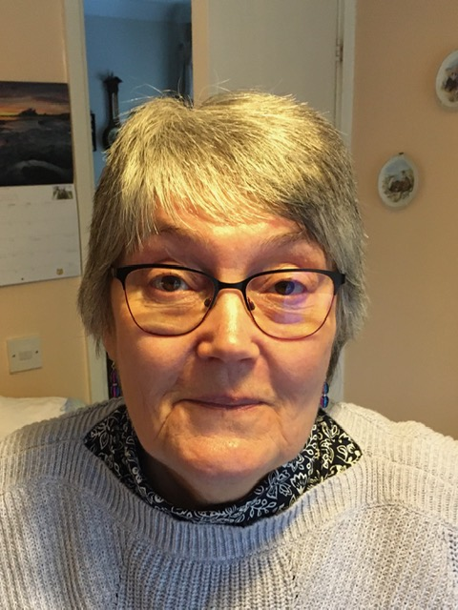
Incumbent (signed) Ven. Angela Martin

Churchwarden (signed) Simon P Morris

Churchwarden (signed) J V Spoor

Date: 29 March 2023

